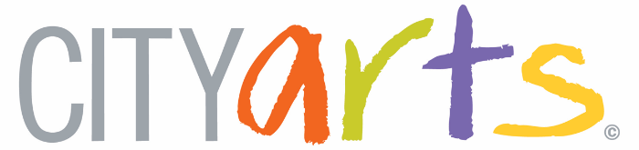

Community Identity Program
Alicka’s Dance of Life
A CITYarts mural project in Ocean Hill, Brooklyn

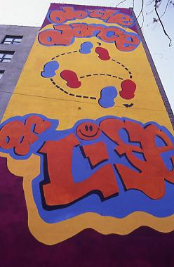
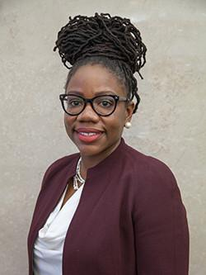

What:
CITYarts will produce and recreate a mural project in Flatbush, Brooklyn to honor CITYarts kid Alicka Ampry-Samuels. Alicka’s Dance of Life, will be painted on an exterior wall near the original location of the mural Alicka helped paint when she was 16-years-old, Do the Dance of Life. This mural will be painted with youth from the Middle School of Art and Philosophy and the community. Today, Alicka Ampry-Samuels works as the HUD Regional Administrator for the Biden administration. CITYarts and NYPD collaboration will invite police officers to the school for students to get to know them in a safe environment

Where:
1920 Union St.
Brooklyn, NY 11233
Who:
Students: Middle School for Art & Philosophy
Danielle Lamb, Principal - MSAP
CITYarts Artist - TBD
Volunteers, Interns, & Staff, CITYarts
Alicka Ampry-Samuel

When:
Spring-Summer 2023
Workshops: TBD
Why:
Assist students in realizing their potential through using the visual arts
Create stronger bonds and teamwork within the student community
Showcase the diversity within the school, neighborhood, and the world
Develop interpersonal, artistic, and technical skills
Build better relationships between youth and the NYPD

